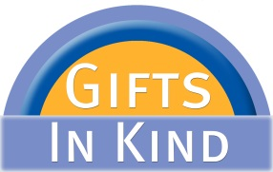 |  |  |  |  |  |  |  |  | United Way of Central New York  Gifts In Kind Participation Application  July 1, 2019 to June 30, 2020 |  |  |  |  |  |  |  |  |  |  |  |  |  |  |  |  |  |  |  | 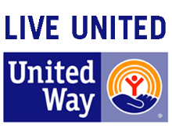
United Way of Central New York’s Gifts In Kind program is locally run and manages large-scale donations of goods from both local and national companies, matching those gifts with member non-profit agencies that can use them best. This support helps non-profits hold down overhead costs, expand capabilities, and ultimately serve more people in the community. The program also promotes environmental stewardship through the reuse and recycling of goods in the community.
An annual fee of $100.00 includes weekly access to the Gifts In Kind staging room, participation in our monthly Distribution Day, as well as other special events.
Please be sure to include a copy of your agency’s IRS 501(c)3 Determination Letter which is required to be on file for tax purposes.
For more information regarding the Gifts In Kind program at United Way of Central New York, please refer to the enclosed brochure, or call the Gifts In Kind Coordinator, Bob Frateschi at 315.428.2223 or email rfrateschi@unitedway-cny.org.
 |  |  |  |  |  |  |  |  |  |  |  |  |  | Gifts In Kind—United Way of CNY
(Detach at line below and return bottom portion)
 | Yes! |  |  | Our agency would like to participate in the Gifts In Kind Program.
 | No thank you |  |  |  |  |  |  | Please remove our agency from your mailing list.
AGENCY INFORMATION:
Agency Name |  |  |  |  |  |  |  |  |  |  |  |  |  |  |  |  |  |  |  |  | Employer Identification Number (EIN)
Mailing Address |  |  |  |  |  |  |  |  |  |  |  |  |  |  |  |  |  |  |  |  |  |  |  |  | Suite/Room #
City |  |  |  |  |  |  |  |  |  |  |  |  |  |  | State |  |  |  |  |  |  |  | Zip Code
Agency Phone |  |  |  |  |  |  |  |  |  |  |  |  |  |  |  |  |  | Agency Website
CONTACT INFORMATION: |  |  |  |  |  |  |  |  |  |  | Should the primary or alternate contacts change, please call or email Bob Frateschi.
Primary Contact Name |  |  |  |  |  |  |  |  |  |  |  |  |  |  |  |  |  | Alternate Contact Name
Primary Contact Title |  |  |  |  |  |  |  |  |  |  |  |  |  |  |  |  |  | Alternate Contact Title
Primary Contact Email |  |  |  |  |  |  |  |  |  |  |  |  |  |  |  |  |  | Alternate Contact Email
Email is our preferred method of contact. Please provide us with current email addresses.
- Return this completed form
- Enclose a check of $100.00 made payable to United Way of CNY
- Enclose a copy of your agency’s IRS 501(c)3 Determination Letter which includes the agency’s nine digit Employer Identification Number (EIN).
(The IRS 501(c)3 Determination Letter must be on file with United Way for tax purposes)
Mail to:
United Way of CNY
ATTN: Bob Frateschi
Gifts In Kind Program
PO Box 2129
Syracuse NY 13220
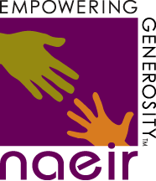
United Way of CNY Gifts In Kind Program is in partnership with
 |  |  |  |  |  |  |  |  |  |  |  |  |  |  |  |  | 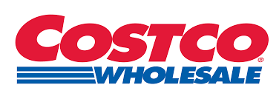
 |  |  |  |  |  |  |  |  |  |  |  |  |  |  |  |  |  |  |  |  |  |  |  |  |  |  |  | revised June 2019
LIKE US ON FACEBOOK

